LinkedIn Article

Title:

What Managing Yarn Charms Taught Me About Digital Marketing

Managing a handmade business is often viewed as simply creating products and posting them online. However, working on my brand, Yarn Charms, has shown me a powerful truth: successful digital marketing requires much more than regular posting.
"Marketing is no longer about the stuff that you make, but about the stories you tell." - Seth Godin

Lesson 1: Data Over Guesswork
Throughout this project, I learned the importance of understanding audience behavior before creating content. By reviewing performance insights and metrics from previous campaigns, a clear pattern emerged: Educational posts consistently generated stronger engagement than purely promotional content. This crucial observation completely guided the content strategy for Project 2. Instead of focusing only on sales, I placed a much greater emphasis on:
- Sharing crochet knowledge and tips.
- Answering frequently asked questions (FAQs).
- Building long-term trust with the audience.

Figure 1: Picture showing Increase in Instagram Insights

Lesson 2: Work Smarter, Not Harder
Another important lesson was the value of consistency across platforms. Managing multiple channels can be overwhelming, but I discovered the power of content re-purposing. Rather than creating completely different content for each platform, existing content was thoughtfully adapted for Instagram, Facebook, LinkedIn, and Reddit. This approach brought two massive benefits:
- It greatly improved content creation efficiency.
- It maintained a very consistent brand identity everywhere.
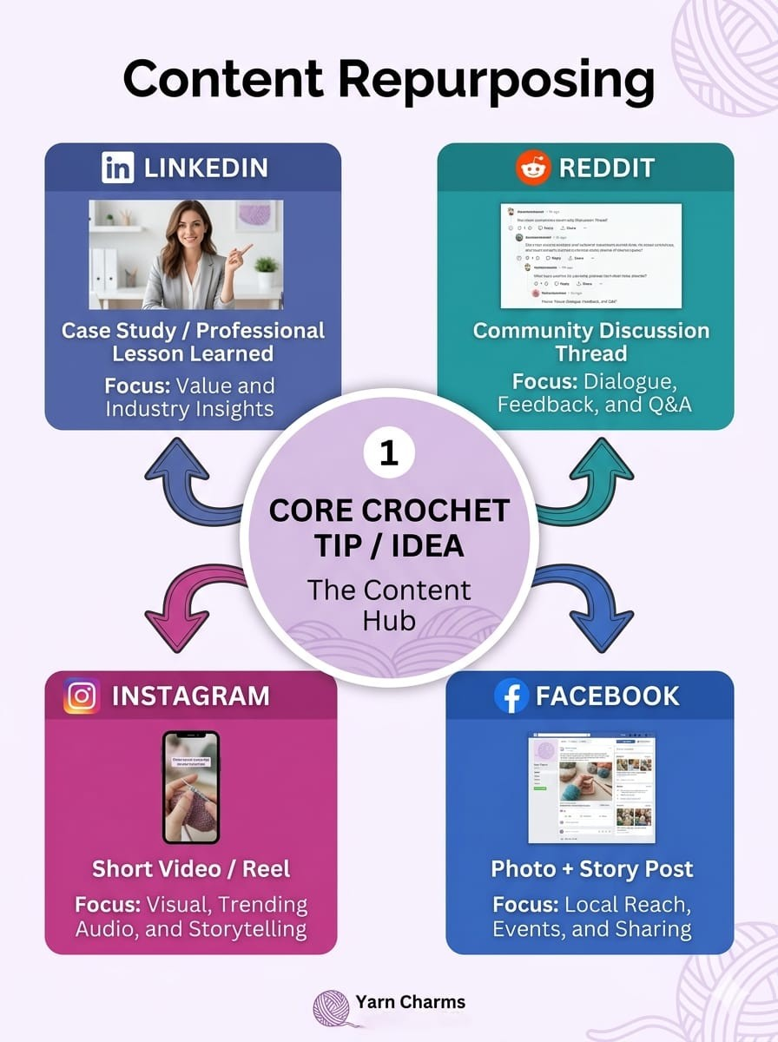
Figure 2: Basic Idea of Content Repurposing

Lesson 3: Conversations Over Sales
The project also reinforced that meaningful engagement is built through authentic conversations rather than constant selling. To bring this to life, I shifted toward interactive marketing elements, including:
- Interactive stories to get daily feedback.
- Polls to let the audience vote on new designs.
- Community-focused content that encouraged active participation.
These steps heavily strengthened my relationships with followers and turned passive viewers into an active community.
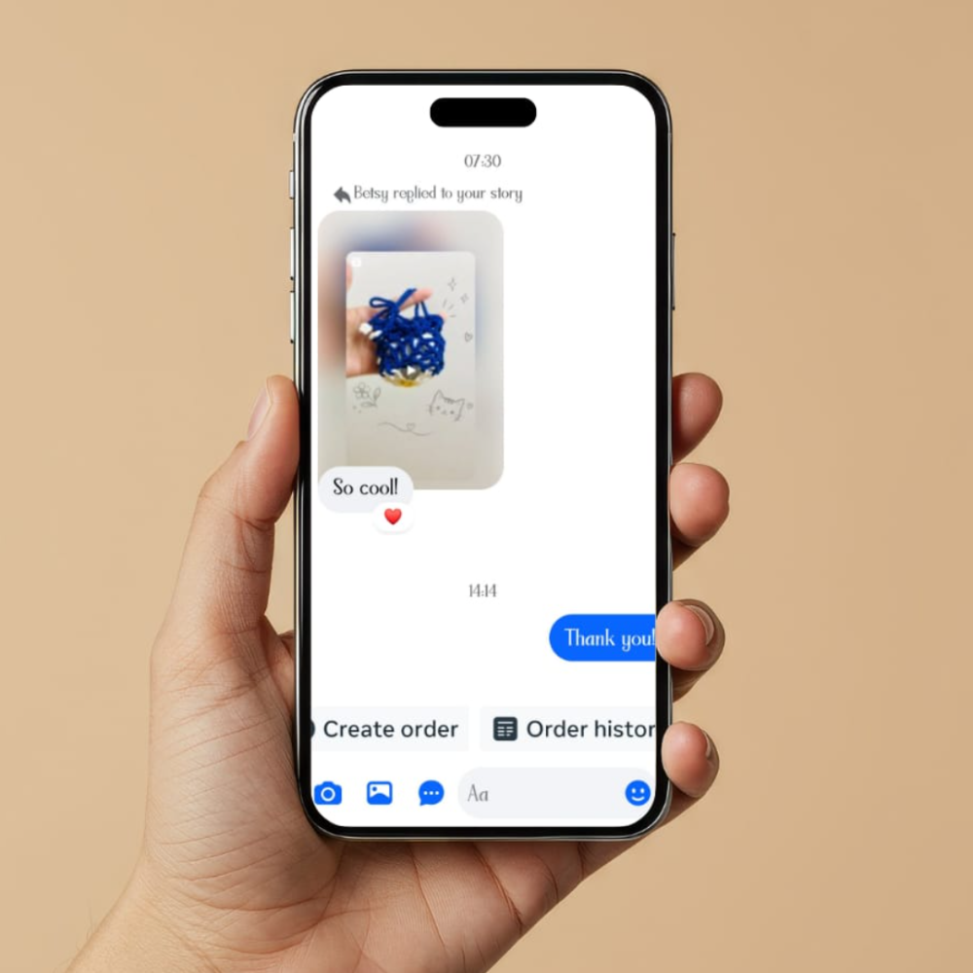
Figure 3: Audience Engagement through Interactive Story

Moving Forward as a Digital Marketer
Managing Yarn Charms has been a valuable opportunity to apply complex digital marketing concepts in a practical, real-world setting. It has strengthened my core skills in:
- Content strategy development
- Campaign optimization
- Audience engagement
- Data-driven decision-making

These are the exact skills that will continue to support my growth as I step into my career as a digital marketer. I'm grateful to DevelopersHub Corporation© for this valuable opportunity.

Published Proof

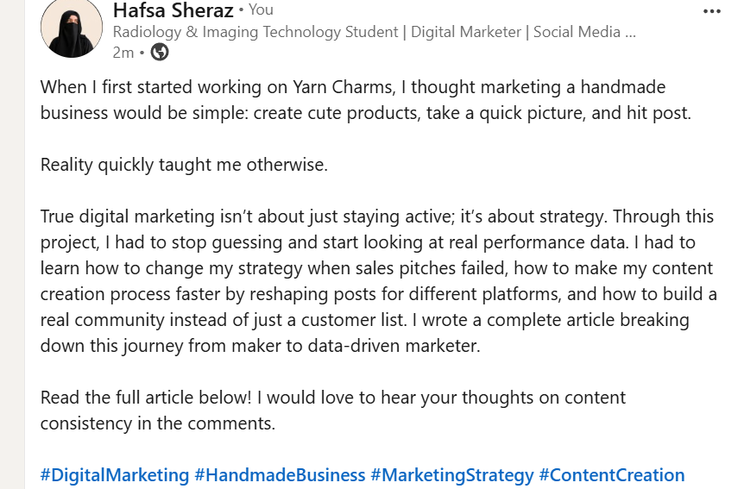
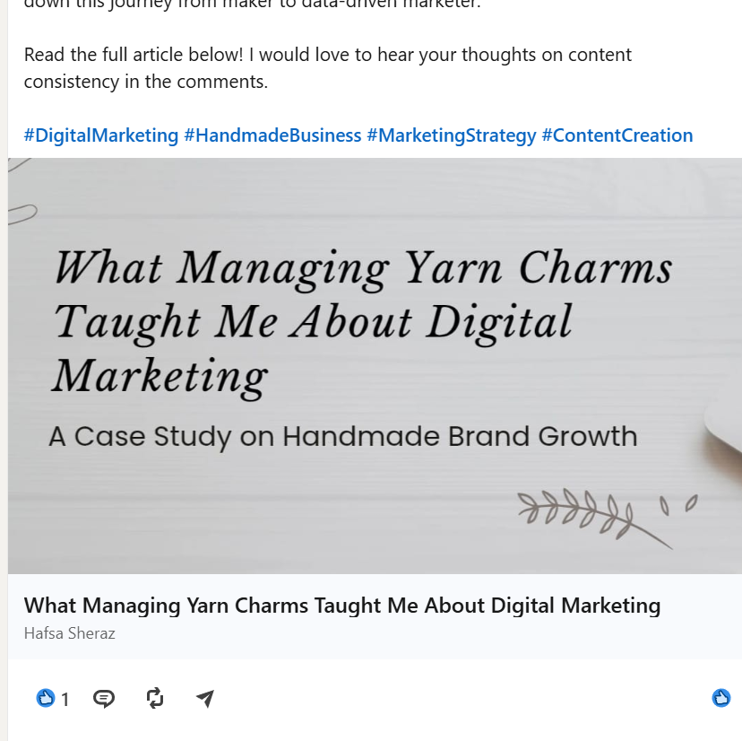

Hyperlink:

What Managing Yarn Charms Taught Me About Digital Marketing - LinkedIn Article

